**Experiment 3**

Crypto Encryption

**Name:** Kashish Jain

**UID:** 2019130022

**Class:** TE Comps

**Objective: -**

The learning objective of this lab is for students to get familiar with the concepts in the secret-key encryption. After finishing the lab, students should be able to gain a first-hand experience on encryption algorithms, encryption modes, paddings, and initial vector (IV). Moreover, students will be able to use tools and write programs to encrypt/decrypt messages.

**Time Analysis**

I used a bat file to use a command to calculate time for each openssl command

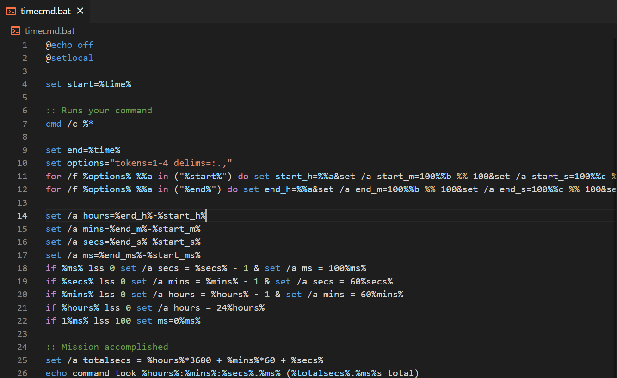

Analysis of different Ciphers



AES-ECB

Encryption - 0.2s

Decryption – 0.11s

Blowfish

Encryption - 0.07s

Decryption – 0.05s

DES

Encryption - 0.06s

Decryption – 0.13s

3DES

Encryption - 0.7s

Decryption – 0.09s

Observations

The results showed that Blowfish has a very good performance compared to other algorithms. Also, it showed that AES has worse performance than 3DES and DES.

**Tasks**

Task 1: Encryption of plain text using different Ciphers

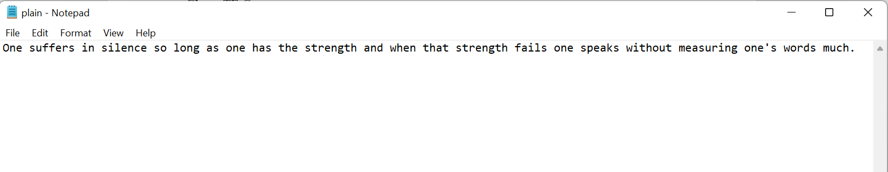

1. Encryption Using aes-128-cbc

In this no extra arguments were given.

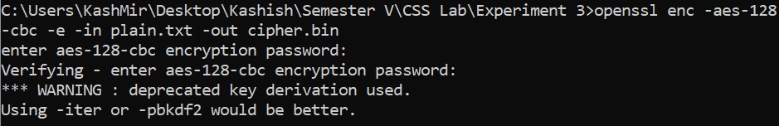

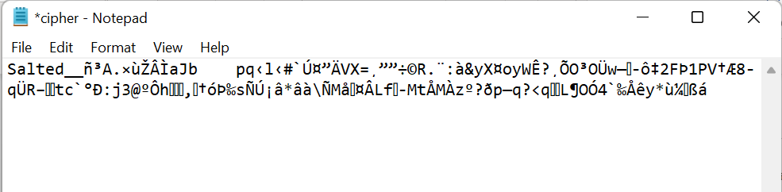

Decryption

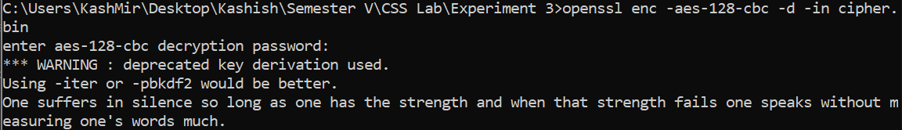

1. Encryption using des

In this instead of providing a password we provide a KEY and IV. If we do not provide these two arguments, both are generated automatically and can be viewed by adding -p.



Cipher File

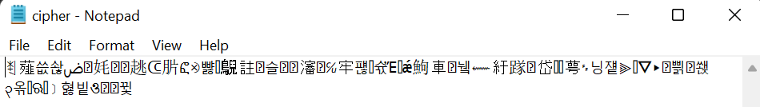

We can observe that here a password is not asked as both KEY and IV is provided

1. Encryption using bf-cbc

Password is provided as argument



Cipher File

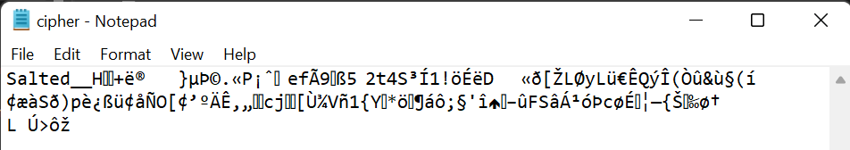

Decryption also accepts password as argument



**Observation**

* In AES key length can be 128-bits, 192-bits, and 256-bits while in DES it is 56 bits. Blowfish has a variable key length from 32 bits up to 448 bits
* Blowfish and DES are 64-bit block ciphers, while AES is a 128-bit block cipher; this is a serious issue in a growing number of applications as 64 block ciphers are easier for attackers to crack.

Task 2: Encryption Mode – ECB vs. CBC

The file pic original.bmp contains a simple picture. We would like to encrypt this picture, so people without the encryption keys cannot know what is in the picture. Please encrypt the file using the ECB (Electronic Code Book) and CBC (Cipher Block Chaining) modes, and then do the following:

1. The file pic original.bmp contains a simple picture. We would like to encrypt this picture, so people without the encryption keys cannot know what is in the picture. Please encrypt the file using the ECB (Electronic Code Book) and CBC (Cipher Block Chaining) modes, and then do the following.
2. Display the encrypted picture using any picture viewing software. Can you derive any useful information about the original picture from the encrypted picture? Please explain your observations.

**Original Picture**



**ECB**

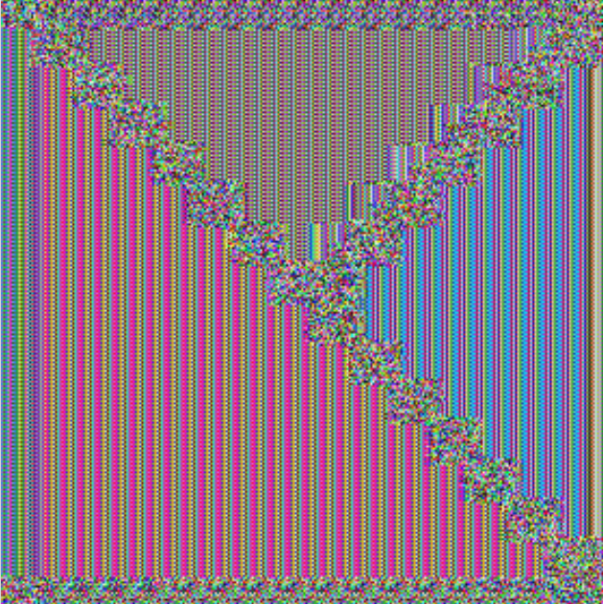

**CBC**



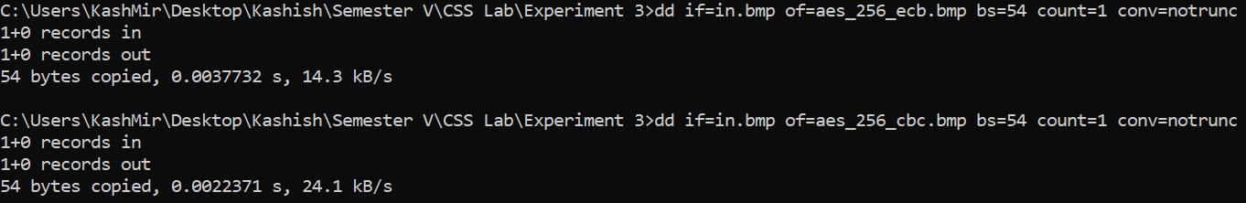

**Observations:**

* I noticed that when using the ECB mode to encrypt the file, the image obtained was not entirely encrypted (the image boundaries remain visible), allowing a third party to readily decipher what the image could be about.
* The CBC mode encryption, on the other hand, completely encrypts the image, making it impossible to see or understand what it was about.
* The fact that the ECB (Electronic Codebook) is essentially the first version of the AES justifies this distinction. It is the most basic type of block cypher encryption, whereas CBC (Cipher Block Chaining) is the most advanced one. With CBC mode encryption, each ciphertext block is dependent on all plaintext blocks processed up to that point. This adds an extra level of complexity to the encrypted data hence harder to decrypt.

Task 3: Encryption Mode – Corrupted Cipher Text

To understand the properties of various encryption modes, we would like to do the following exercise:

1. Create a text file that is at least 64 bytes long.

2. Encrypt the file using the AES-128 cipher.

3. Unfortunately, a single bit of the 30th byte in the encrypted file got corrupted. You can achieve this

corruption using ghex.

4. Decrypt the corrupted file (encrypted) using the correct key and IV.

Please answer the following questions: (1) How much information can you recover by decrypting the corrupted file, if the encryption mode is ECB, CBC, CFB, or OFB, respectively? Please answer this question before you conduct this task, and then find out whether your answer is correct or wrong after you finish this task. (2) Please explain why. (3) What are the implication of these differences?

**ECB**

Original Encrypted Text

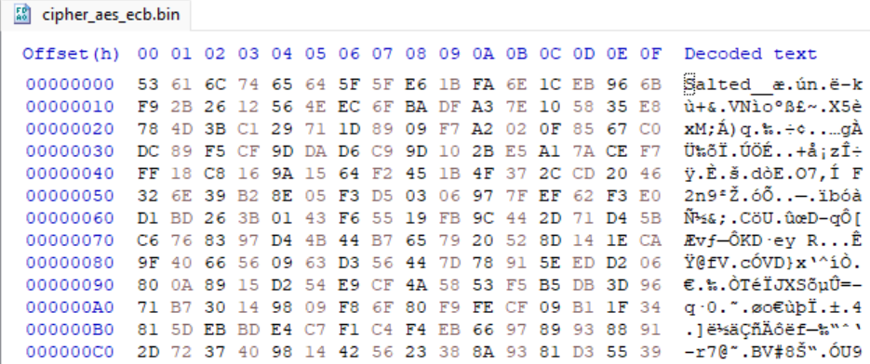

Corrupted Encrypted Text

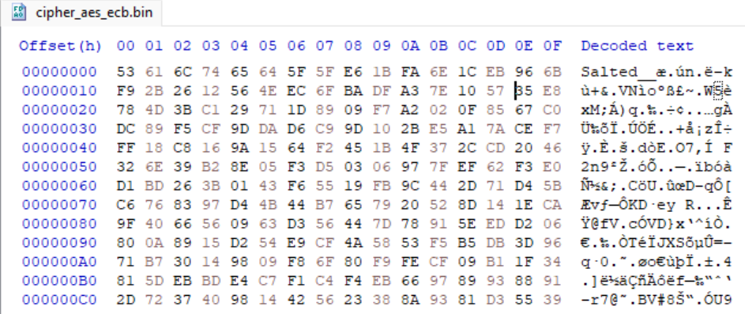



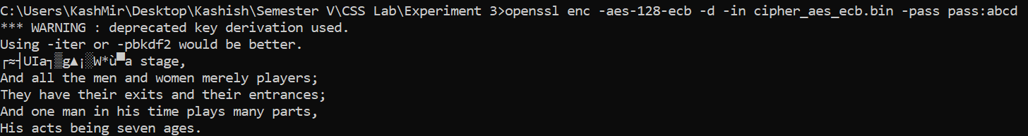

**CBC**

Original Encrypted Text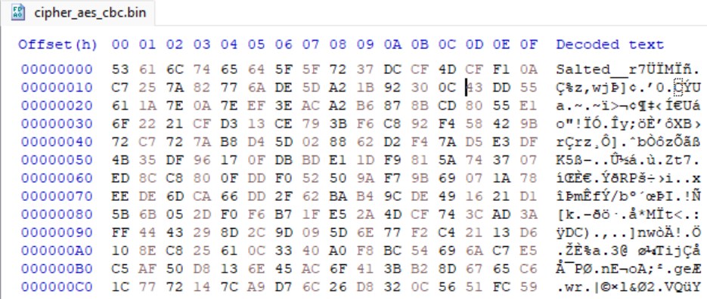

Corrupted Encrypted Text

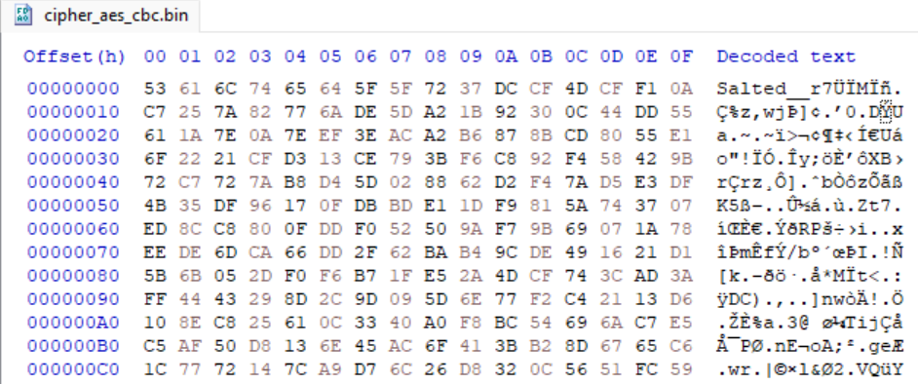

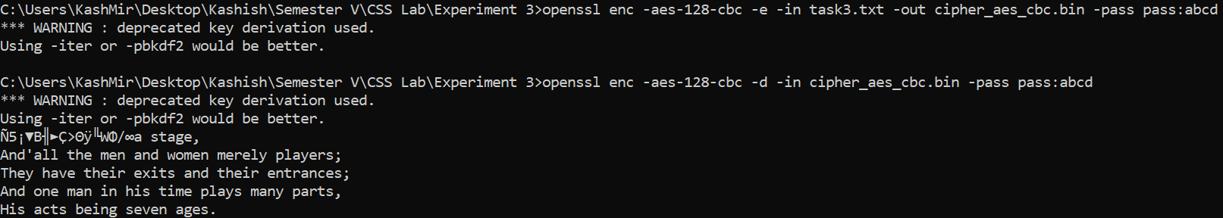

**CFB**

Original Encrypted Text 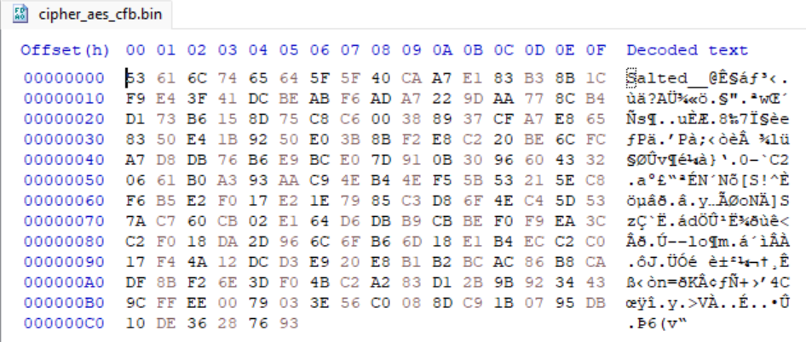

Corrupted Encrypted Text

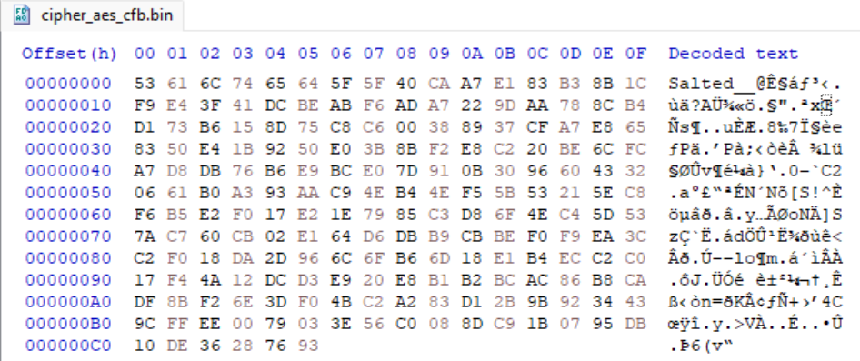

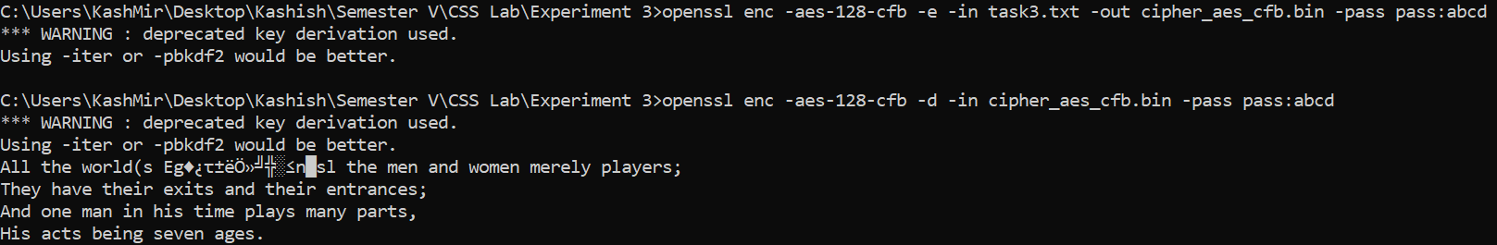

**OFB**

Original Encrypted Text 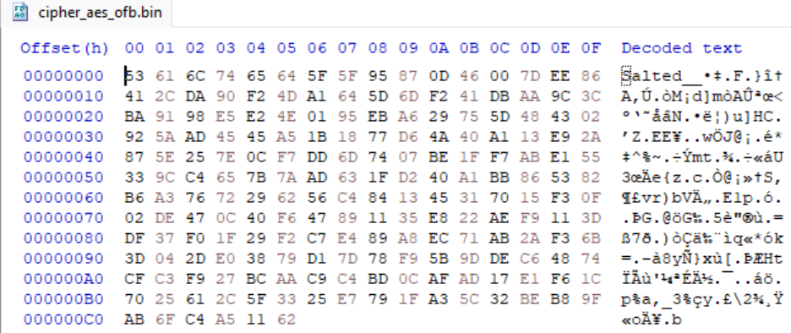

Corrupted Encrypted Text

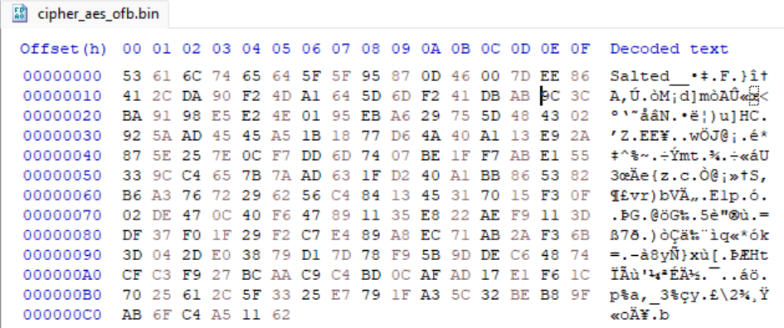

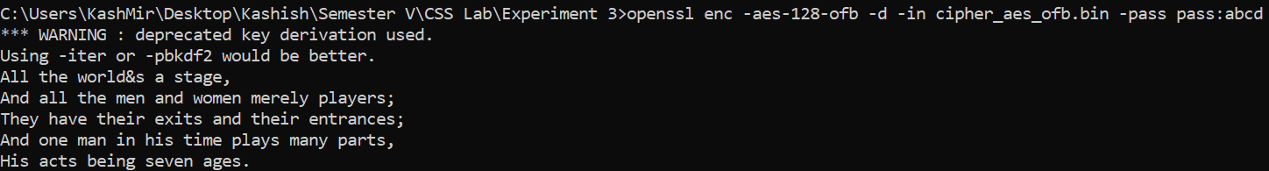

**Observation**

* ECB - Since each plaintext block is encrypted and decrypted separately with ecb mode encryption, only the block containing the faulty byte is corrupted; the rest of the text is unaffected. Because there are no dependencies on other blocks in this mode, encryption and decryption can be done by multiple threads at the same time.
* CBC - As we know, in the cbc mode, input and output are chained, thus the plain text block is XORed with the encrypted block from the previous pass, and the chain continues. So I deduced and understood that if one bit of the actual plain block is corrupted, the entire chain will have corrupted bits, resulting in a completely corrupted text, but if only one bit of the ciphertext is corrupted, only two received plaintext blocks will be corrupted, allowing the original data to be recovered.
* CFB - The cfb mode is similar to the cbc mode, with the exception that the previous round's ciphertext must be encrypted before being added to the plaintext bits. Both encryption and decoding must be done with the same encryption technique. I discovered that when one ciphertext bit is corrupted, only the next two plaintext blocks are affected.
* OFB - The keystream bits formed in the case of ofb mode are utilised for the encryption of following data blocks, and as a result, the operation of this mode is identical to that of a conventional stream cypher. In this situation, I discovered that if one bit of a plaintext or ciphertext message is corrupted, only one ciphertext or plaintext bit is also corrupted.

Task 4: Padding

For block ciphers, when the size of the plain text is not the multiple of the block size, padding may be required.

In this task, we will study the padding schemes. Please do the following exercises:

1. The openssl manual says that openssl uses PKCS5 standard for its padding. Please design an experiment to verify this. In particular, use your experiment to figure out the paddings in the AES encryption when the length of the plaintext is 20 octets and 32 octets.
2. Please use ECB, CBC, CFB, and OFB modes to encrypt a file (you can pick any cipher). Please report which modes have paddings and which ones do not. For those that do not need paddings, please explain why.

**Original file (20 octets)**

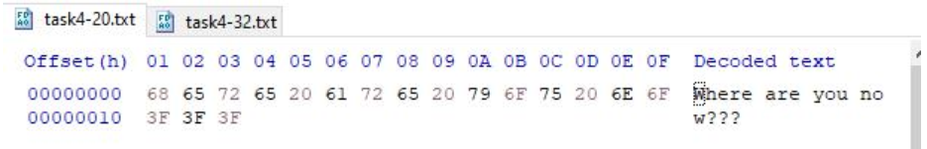

**Original file (32 octets)**

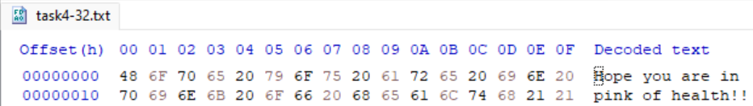

1. CBC

Aes-128-cbc for 20 octets

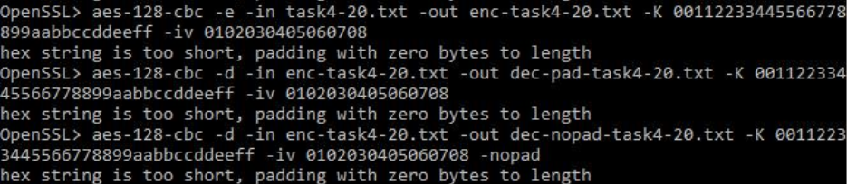

Encrypted File

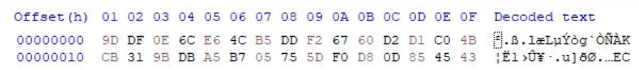

Decrypted file (Without padding)



Decrypted file (With padding)



Aes-128-cbc for 32 octets

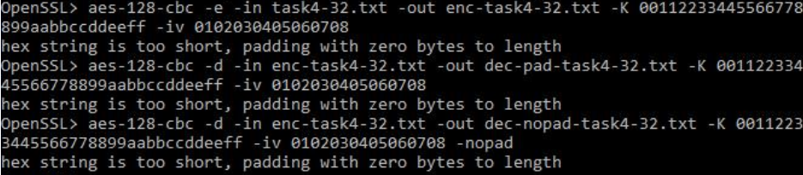

Encrypted file

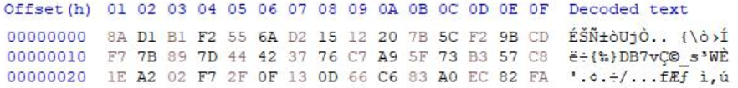

Decrypted file (Without padding)

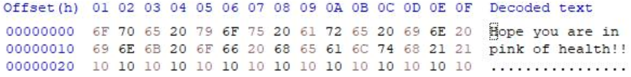

Decrypted file (With padding)

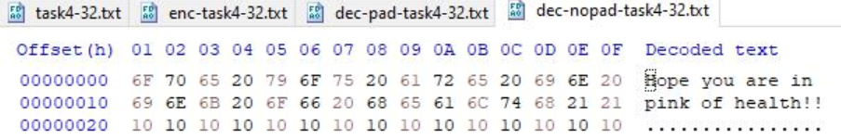

1. ECB

Aes-128-ecb for 20 octets

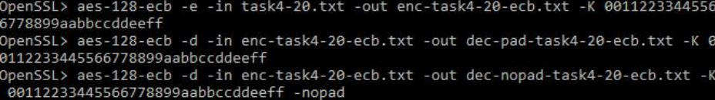

Encrypted File

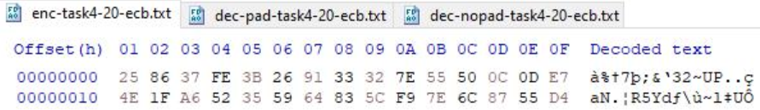

Decrypted file (Without padding)



Decrypted file (With padding)



Aes-128-ecb for 32 octets

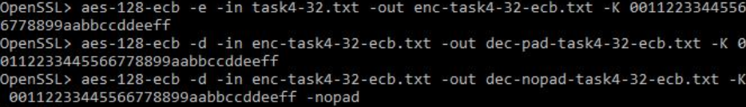

Encrypted file

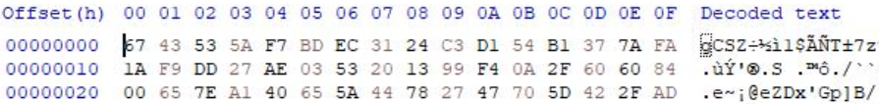

Decrypted file (Without padding)



Decrypted file (With padding)

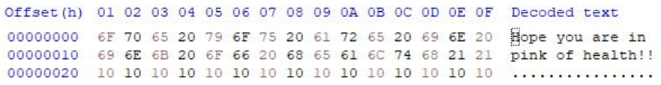

1. CFB

Aes-128-cfb for 20 octets

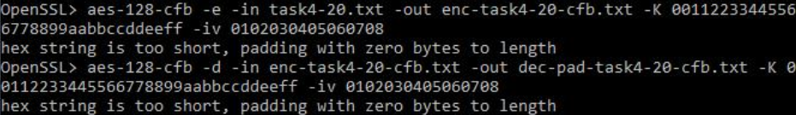

Encrypted File

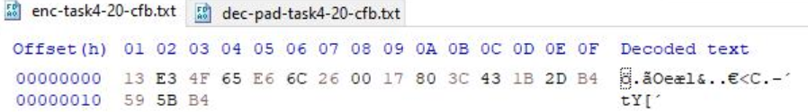

Decrypted file (Without padding)

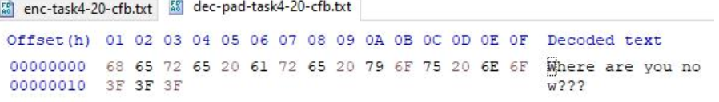

Decrypted file (With padding)



Aes-128-cfb for 32 octets

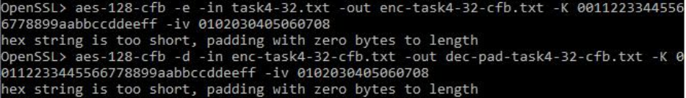

Encrypted file

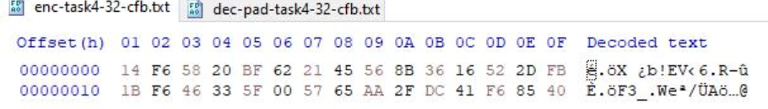

Decrypted file (Without padding)

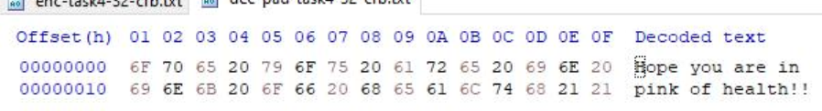

Decrypted file (With padding)



1. OFB

Aes-128-ofb for 20 octets

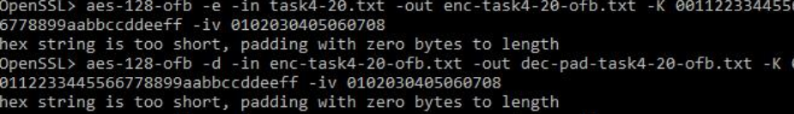

Encrypted File

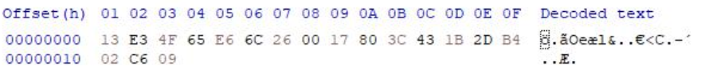

Decrypted file (Without padding)

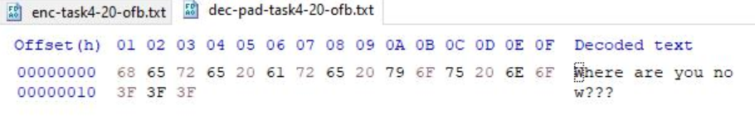

Decrypted file (With padding)



Aes-128-ofb for 32 octets

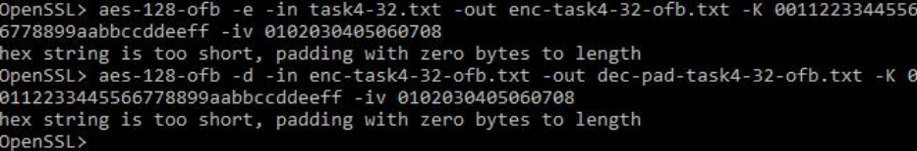

Encrypted file

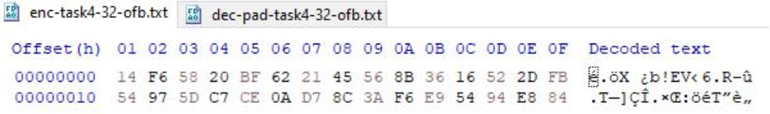

Decrypted file (Without padding)

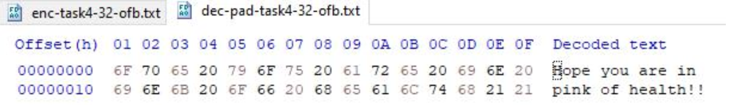

Decrypted file (With padding)



The size of CBC and ECB encrypted files with the nopad option is 12 bytes more for the 20 bytes file and 16 bytes larger for the 32 bytes file, however the size of OFB and CFB decrypted files is the same, as shown in the screenshots above.

**Observations**

* I noticed that the size of the ecb and cbc files after decryption increases by 12 bytes for the task4-20.txt, which was originally 20 bytes, and by 16 bytes for the task4-32.txt, which was originally 32 bytes, indicating that padding was required during encryption. This can be explained by the fact that these are block cyphers, which require that the plaintext be an exact multiple of the block length, so if that is not the case, padding is used to fill in the blanks.
* And I noticed that no padding was required in the cfb and ofb modes because the file size after decryption did not increase. This behaviour can be explained by the fact that these are stream cyphers, and streaming modes of operation can encrypt and decrypt messages of any size, so they do not require padding.

Task 5: Programming using the Crypto Library

So far, we have learned how to use the tools provided by openssl to encrypt and decrypt messages. In this task, we will learn how to use openssl’s crypto library to encrypt/decrypt messages in programs.

OpenSSL provides an API called EVP, which is a high-level interface to cryptographic functions. Although OpenSSL also has direct interfaces for each individual encryption algorithm, the EVP library provides a common interface for various encryption algorithms. To ask EVP to use a specific algorithm, we simply need to pass our choice to the EVP interface. A sample code is given in http://www.openssl. org/docs/crypto/EVP_EncryptInit.html.

Activate MyEnv

Please get yourself familiar with this program, and then do the following exercise. You are given a plaintext and a ciphertext, and you know that aes-128-cbc is used to generate the ciphertext from the plaintext, and you also know that the numbers in the IV are all zeros (not the ASCII character ‘0’). Another clue that you have learned is that the key used to encrypt this plaintext is an English word shorter than 16 characters; the word that can be found from a typical English dictionary. Since the word has less than 16 characters (i.e. 128 bits), space characters (hexadecimal value 0x20) are appended to the end of the word to form a key of 128 bits. Your goal is to write a program to find out this key. You can download a English word list from the Internet. We have also linked one on the web page of this lab. The plaintext and ciphertext is in the following:

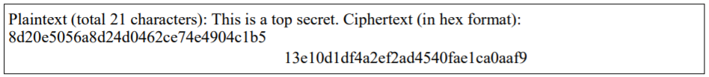

Words.txt file

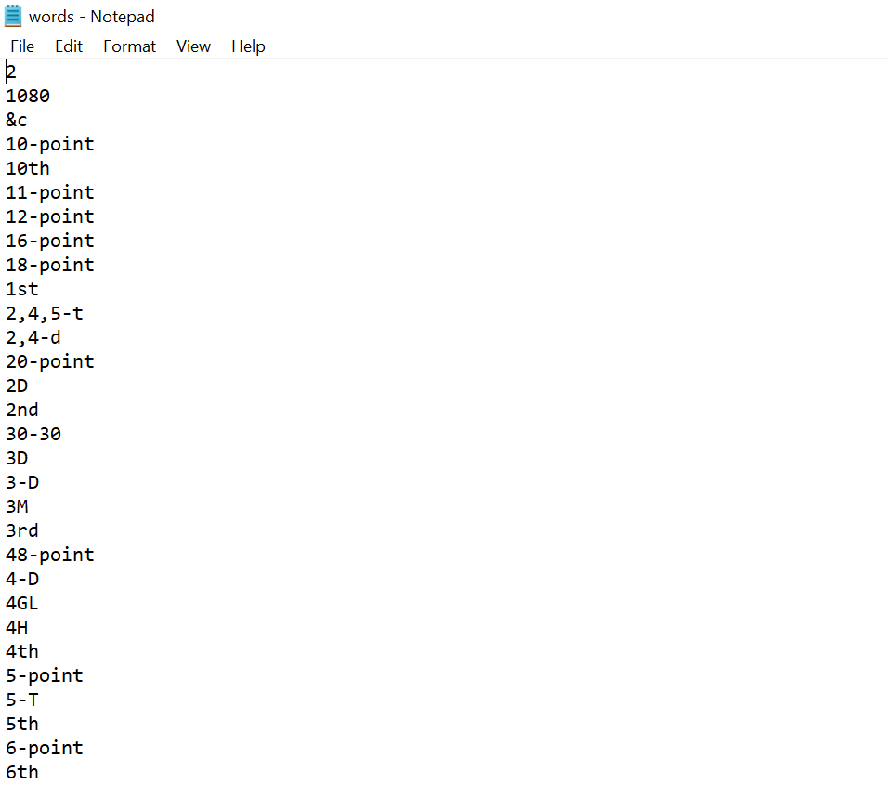

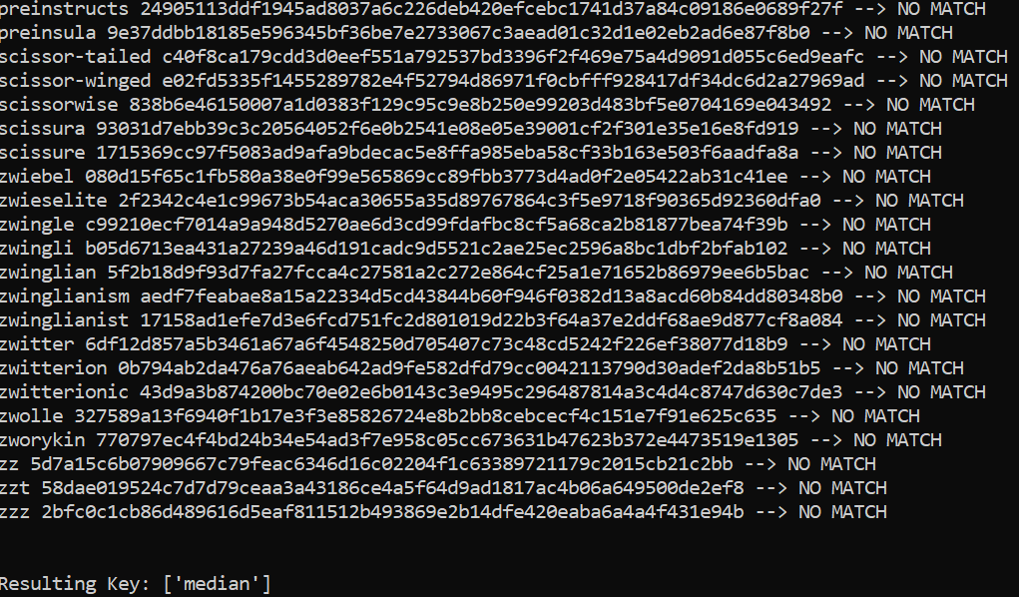

Code

from Crypto.Cipher import AES

from Crypto.Util.Padding import pad

cipherHex = "8d20e5056a8d24d0462ce74e4904c1b513e10d1df4a2ef2ad4540fae1ca0aaf9"

plainText = b"This is a top secret."

result = []

file = open('words.txt', 'r')

lines = file.readlines()

words = [str.strip(line) for line in lines]

for word in words:

if len(word) >= 16:

continue

word = word.lower()

key = word.encode() + b' '*(16-len(word))

cipher = AES.new(key, AES.MODE_CBC, iv=bytes.fromhex('0'*32))

ciphertext = cipher.encrypt(pad(plainText, AES.block_size))

is_matched = "--> NO MATCH"

if bytes.hex(ciphertext) == cipherHex:

is_matched = "--> MATCH"

result.append(word)

print(word, bytes.hex(ciphertext), is_matched)

print("\n\nResulting Key:",result)

Observations

**The key is “median”**

I discovered that by brute forcing the key using the pycryptodome module in Python using the given plain text, cypher text, and iv, I was able to find the key.

**Conclusion**

* In this experiment, I learned about various encryption methods such as AES and their different encryption modes such as ECB, CBC, CFB, OFB, etc and I implemented them using Openssl utility.
* ECB mode encrypts the identical plain text blocks to identical encrypted text blocks and hence it is less secure.
* From the experiment, I deduced that ECB and CBC employ padding while encrypting, whereas the other two don't. ECB and CBC are block cyphers, but CFB and OFB are stream cyphers, as evidenced by this.
* In OFB mode, if the single digit of the 30th byte corrupted, then in plain text that only that byte or character is corrupted. Thus, only OFB mode shows the most promising result in task 3 and almost all the texts are recovered.
* I concluded from task 5 that if I have the ciphertext and the key space, I can easily locate the plaintext using the brute force method.

**Github Links**

Repository

<https://github.com/kashishvjain/CSS-Lab>